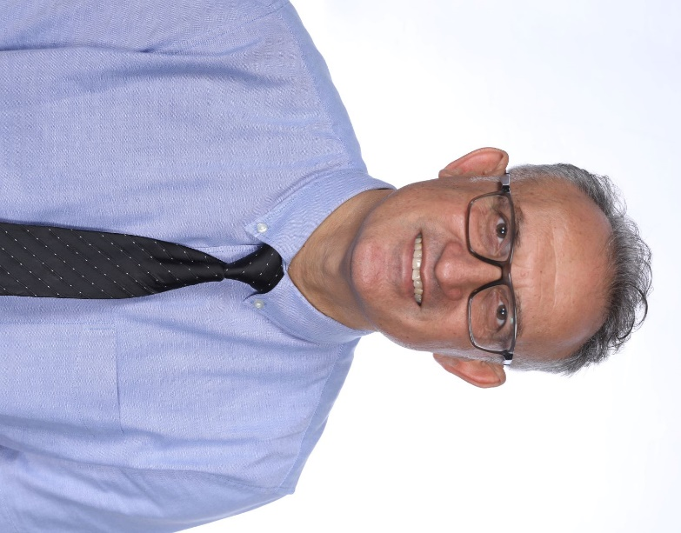

Ziya Tüzel
Born in 1969, he completed his BA in Mathematics at Hacettepe University in Ankara. His career as a mathematics teacher spanned from 1994 to 2019 across various schools. He also played a pivotal role as the organizing secretary on the Executive Board of the Cyprus Turkish Secondary Education Teachers' Union (KTOEÖS). In 2019, he took up the position of principal at Lefke Gazi High School. Since then, for the past three years, he has been working as the principal of 19 Mayıs Turkish Maarif College.
Additionally, he is actively involved in various non-governmental organizations. He holds the position of President at the Kyrenia Thought Association (Girne Düşünce Derneği) and is a member of the Board of Directors of the New Cyprus Association (Yeni Kıbrıs Derneği).

