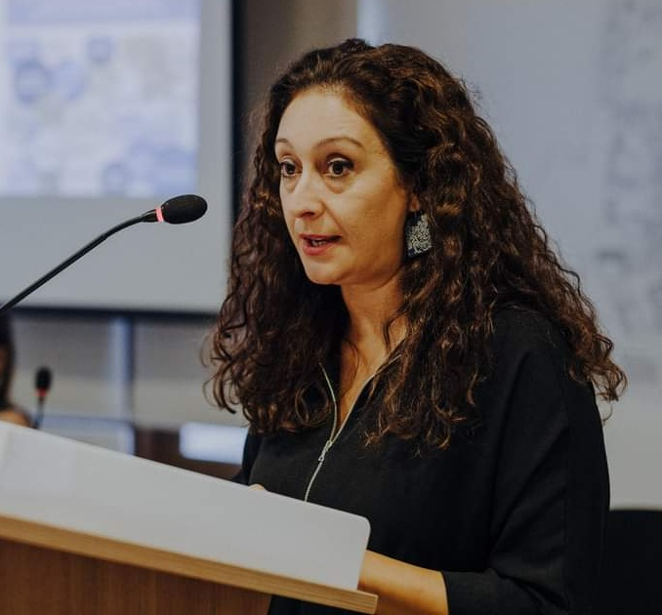

Dr Elena Papamichael works as a First Educational Planning Officer at the Cyprus Pedagogical Institute (Ministry of Education, Sport and Youth) and teaches at the Open University of Cyprus. She is the author of a teachers’ handbook on intercultural education 'Discovering the Elephant' (2013), and the main author of the Ministry’s antiracist policy ‘Code of Conduct against Racism and Guide for Managing and Recording Racist Incidents’ (2014). She has been involved in in-service teacher training for several years and has contributed to the curriculum development and reform. She participates in various European projects and interministerial and interdepartmental committees.

