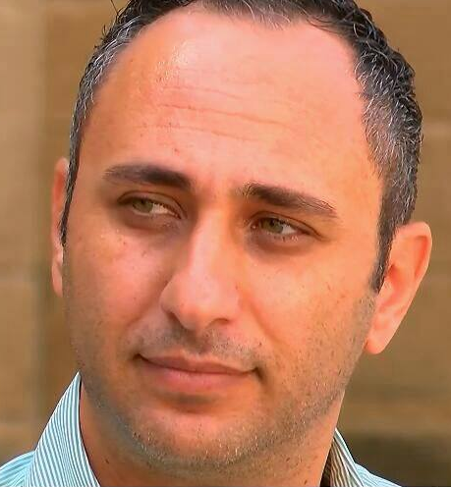
Prof. Dr Ahmet Güneyli, Cypriot academic. He completed his undergraduate education at the Teachers' Training Academy in Cyprus. He completed his master's and doctoral education at Ankara University, Faculty of Educational Sciences. His fields of study are educational sciences, language education, curriculum development and teacher education. Since 2004, he has been working as an academician. Currently, he is a lecturer and head of the department at the Faculty of Education at the European University of Lefke. In addition to teaching at the university, Güneyli is also involved in curriculum development, textbook writing and teacher training in the Turkish Cypriot community. He has been involved in projects related to education in the Turkish Cypriot community and the European Union and has articles and books on educational sciences published at national and international level. Many of these studies are related to peace education and educational administration.

