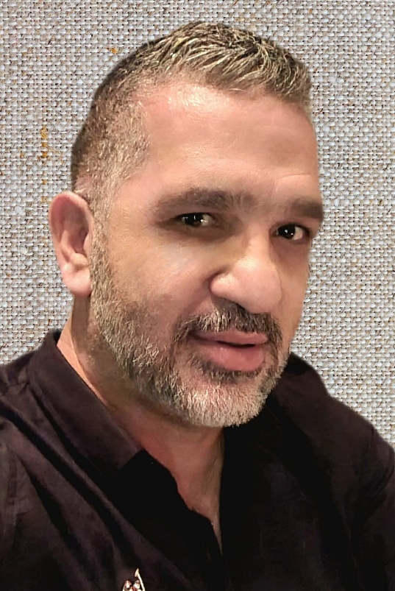
George Konstantinou is a graduate of the Cyprus Pedagogical Academy and holds a master's degree in Educational Administration and Leadership from the Open University of Cyprus. He has been working in Public Primary Education since 1987, while since 2012 he has held the position of Principal of Primary Education.
He is actively involved in European programs, is an ambassador and award-winning member of etwinning and has coordinated European ERASMUS+ projects in the categories KA1 for learning mobility of school staff, KA229 for exchange partnerships between schools and KA201 Strategic Partnerships concerning the development and strengthening of transnational collaborations between bodies/organizations active in the field of education, to produce innovative results.

