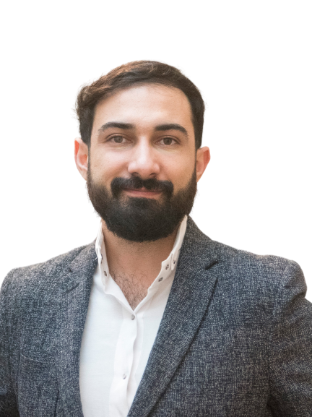
Çağrı Peköz
Preschool Principal-Teacher in a small, culturally diverse preschool and part-time lecturer in Early Childhood Education. Currently pursuing a PhD in Childhood Studies, with the thesis 'Existing in Monocultural Education: Educational Experiences of Immigrant Children.' Influenced by critical pedagogy, the focus of the research interest is understanding prejudice and bias phenomena in the educational context.

