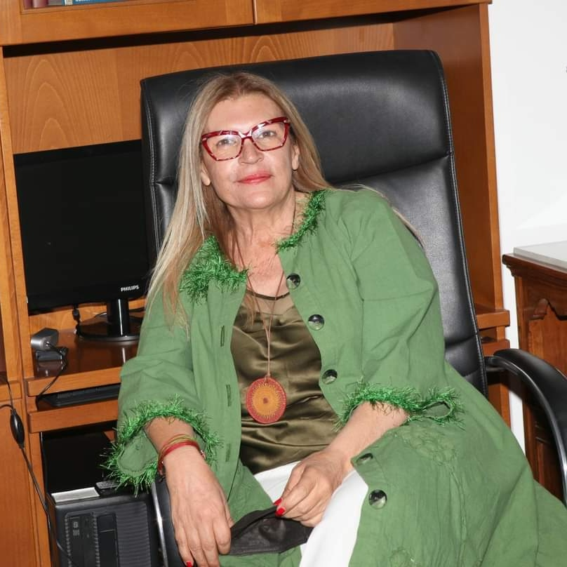

Andri Charalambous, originally from Agios Ambrosios of Kyrenia and now a resident of Nicosia, holds a Degree in Greek Philology from the Kapodistrian University of Athens and a Master in Educational Leadership from the European University. She has 34 years of service and served in many schools mainly in the Nicosia District as a simple teacher, Vice Principal., Vice Principal A and as a Principal. In the previous three years she was the Principal of the Katholikis Gymnasium in Limassol and from this year she serves as the Principal of the Acropolis High School.

